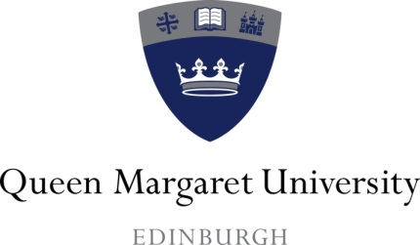 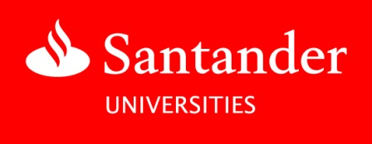

***Santander Universities***

***Student Online Self-Development Programme***

**GUIDELINES FOR QMU APPLICANTS**

Santander Universities UK supports QMU through a variety of scholarships, bursaries and awards. These include generous bursaries for new students, awards for research or study opportunities, grants for community projects, paid internships and entrepreneurial support for start-ups.

The University is grateful for this support which greatly enhances the experience of those students and graduates who receive this funding.

New for 2020/2021 is the Santander Student Online Self-Development Programme.

Santander has joined forces with high performance consultancy [Sporting Edge](http://www.sportingedge.com) to run an online learning experience to help students reach their potential. The flexible on-demand course will focus on performance themes including resilience, confidence, wellbeing, motivation, and much more. Once finishing each module, students will have the opportunity to consolidate their learning and complete an online quiz for the chance of winning a **£10,000 Santander Development Grant.**

Applications are now invited from all students to participate in the Santander Student Online Self-Development Programme. The QMU Santander Panel consisting of QMU senior staff will assess and select the participating students.

Please read the following carefully before applying:

1. You must be a current undergraduate, postgraduate or research student.
2. Applications will only be accepted if they have been submitted online via the Santander Universities Scholarship Platform – [www.becas-santander.com/en](http://www.becas-santander.com/en)

You must register to use the portal before submitting your application.

To find QMU’s listing, click on the ‘Search more scholarships’ function on the homepage and enter ‘Queen Margaret University’.

Please note that by applying to the online course through the Santander Scholarship Platform you are giving your consent:

* To participate in the Santander Student Online Self-Development Programme.
* For your personal data (such as name and email address) to be shared with Santander (including associated companies of Santander, where applicable) and used for administrating the competition and delivery of the prize.

All personal data, when shared with Santander will be processed in accordance with the Santander privacy policy: <https://www.santander.co.uk/personal/support/customer-support/legal-information>

1. All applications to the online course will be reviewed individually and in the context of all the applications received.
2. The application deadline is 12 midnight on Friday 6th November 2020. Late applications will NOT be accepted.
3. All applicants will be informed on Monday 30th November 2020 by email from the QMU Development & Alumni Office.
4. 19 QMU students will be selected to take part in the programme.
5. The names and email addresses of the successful students selected by QMU to take part in the online course will be shared with Santander Universities UK and Sporting Edge. Sporting Edge will send participating students an email providing them with a link to the online content.
6. Students will be able to complete the online course from Monday 11th January 2021 until Friday 19th February 2021. The online material will be accessible to students until mid-March 2021.
7. Students must complete 8-hours of digital learning content.
8. All students who complete the 8-hour content and quizzes will receive a digital certificate via email by the end of March 2021.
9. Four Santander Development Grants of £10,000 are available to four students from across all participating UK universities. The winning students will be selected by the Santander Universities UK team. The winning students will be those who have completed the online course (including all of the online module tests) and who have achieved the highest scores, overall, across all of the online module tests.
10. Students must complete the online course and all of the online module tests before the Friday 19th February 2021 to be eligible to win one of the four development grants. The four winners will be informed on Wednesday 24th February 2021 by email from the Director of Santander Universities UK.
11. QMU will be responsible for paying the development grant to a winning QMU student (where applicable). Monies will be credited to the winning student’s bank account.
12. By participating in the online course, students mustagree to attend the annual Santander Scholars’ Reception (in-person or virtual) and write a 1000-1500 word report on their experience. Reports should be sent to the Development & Alumni Office at [santander@qmu.ac.uk](mailto:santander@qmu.ac.uk) within six months of the programme taking place.
13. Each participating student must agree to take part in QMU and Santander Universities UK publicity, for example for the QMYOU alumni magazine, leaflets, booklets, web pages, social media and other media channels.
14. The decision of the QMU Santander Panel is final. No correspondence will be entered into.

**Donna Cochrane**

**Development & Alumni Office**

[**santander@qmu.ac.uk**](mailto:santander@qmu.ac.uk)

**October 2020**